Aim:

9) Installation of OpenStack and creation of Virtual
machines

To install of openstack and creation of virtual machine in linux system.

Steps:

- Update all the file in the ubunttu by sudo apt update
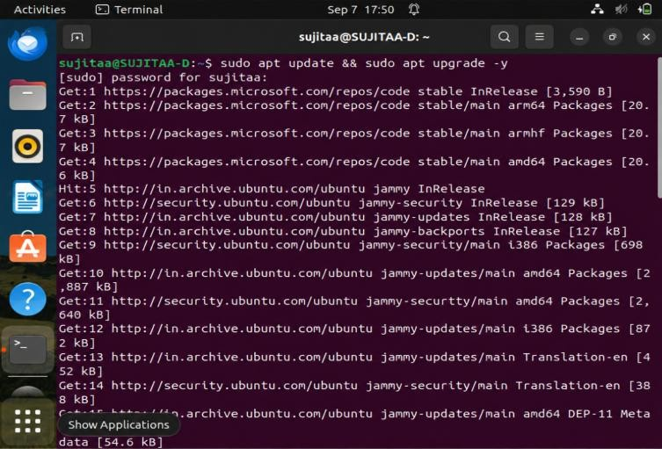

- Install the packages to build the openstack
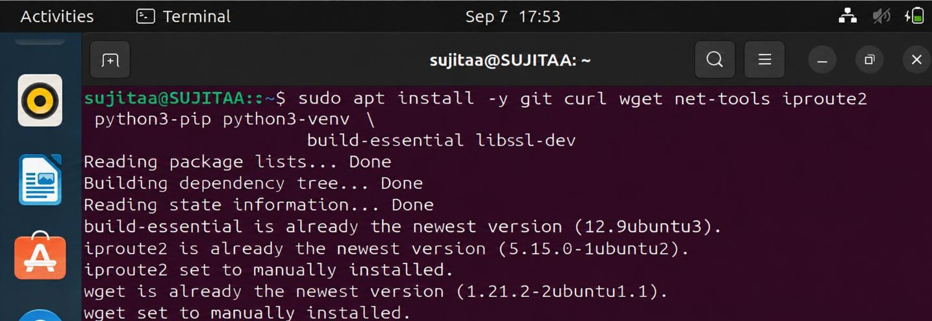

- Add the user stack to the ubunttu especially for the openstack and give the sudo privilege for the user stack and add to the group
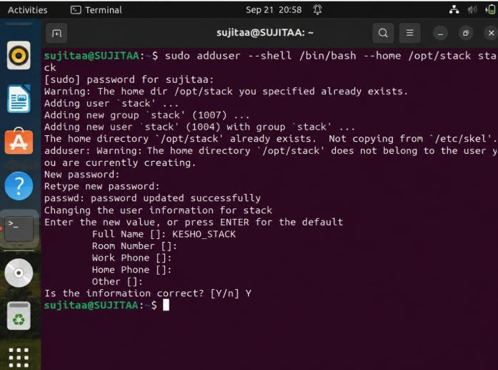

- Set no password for all
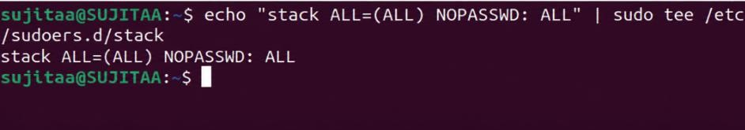

- Give the privileges for the user stack
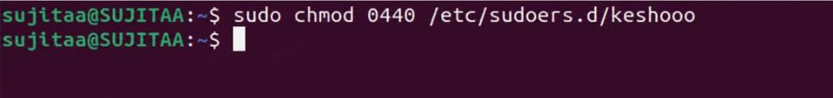

- open the keshoo as sudo user by the command sudo su - stack

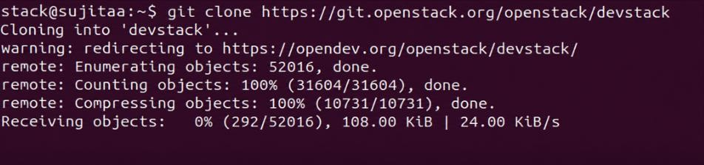

- go to home directory and download the openstack from the git by cloning the git .
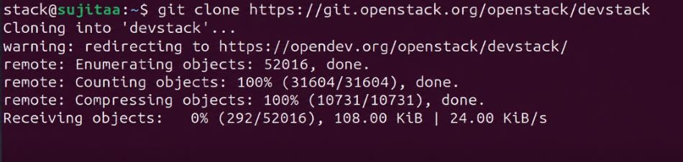

- Move to the devstack directory
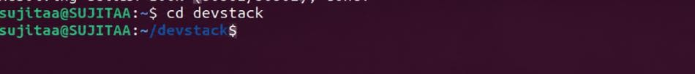

- Change the configuration file in the local.conf

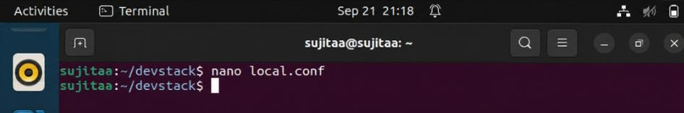

Update the below line and give password for each

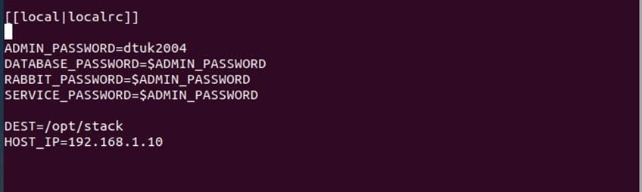

- Run the openstack by the ./stack.sh

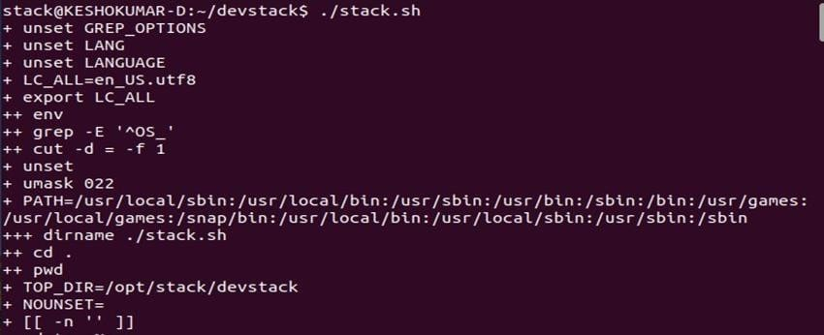
- Visit the IP address that you have configured in the local.conf and login with the password configured in the local.conf
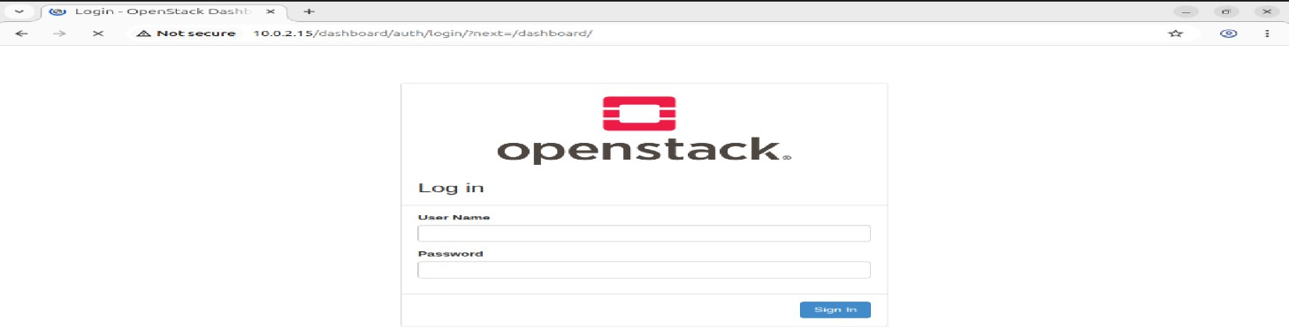

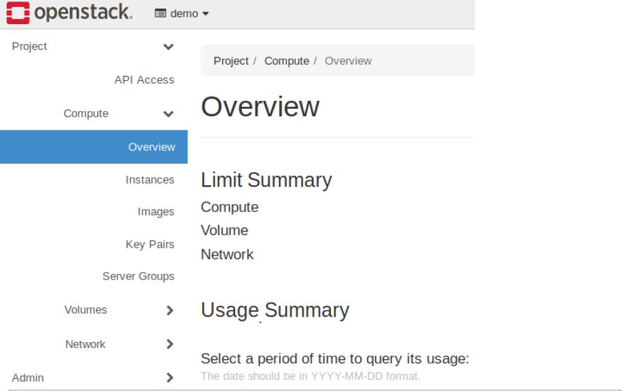
- Create a Virtual Machine using openstack glace service using the following command
  - Source OpenStack Credentials. source devstack/openrc admin admin
(Replace admin with your actual project and username if different). Verify Image and Flavor.
  - Checkout the image list

openstack image list openstack flavor list
Note the name or ID of the image and flavor you intend to use.

  - Create a Key Pair (if not already done): openstack keypair create mykey > mykey.pem chmod 600 mykey.pem
  - Create a Network

DevStack typically creates a default network. You can list existing networks:

openstack network list. If you need to create a new one, this involves creating a network, subnet, and router, and connecting them. Launch the Virtual Machine.
openstack server create --image <image_name_or_id> --flavor <flavor_name_or_id>
--nic net-id=<network_id> --key-name mykey my-first-vm

Replace <image_name_or_id>, <flavor_name_or_id>, and <network_id> with your chosen values. my-first-vm is the desired name for your VM. Verify VM Status and IP Address.
openstack server list

Look for your VM and its assigned IP address. Access the VM. ssh -i mykey.pem cirros@<vm_public_ip>

Result:

Thus the installation of openstack and creation of virtual machine in linux system has been executed successfully and output has been verified.

